湖南科技大学计算机科学与工程学院

## 数据库系统 课程设计报告

专业班级： 22计算机与科学技术7班

姓名： 周俊哲 学号： 2205010711

指导教师： 张世文

时间：

地点： 逸夫楼431

指导教师评语：

签名：

年

月

日



成绩：

等级：

1. 课程设计题目

**题目 3 人事管理系统**

1. 课程设计目的

数据库系统课程设计是为了配合学习数据库系统原理及应用开发而设置的，是计算机科

学与技术、大数据、信息安全、物联网工程、软件工程、智能制造等专业集中实践的教学环

节，是将关系数据库理论知识转化为解决实际问题能力的重要环节。数据库系统课程设计目

的在于加深对关系数据库理论知识的理解，通过使用具体的 DBMS，掌握一种实际的数据

库管理系统并掌握其操作技术，熟练掌握使用数据库前端开发工具（如 VB、C++、Java、 JSP、Delphi、PowerBuilder 等），进一步提高同学们运用数据库技术解决实际问题的能力

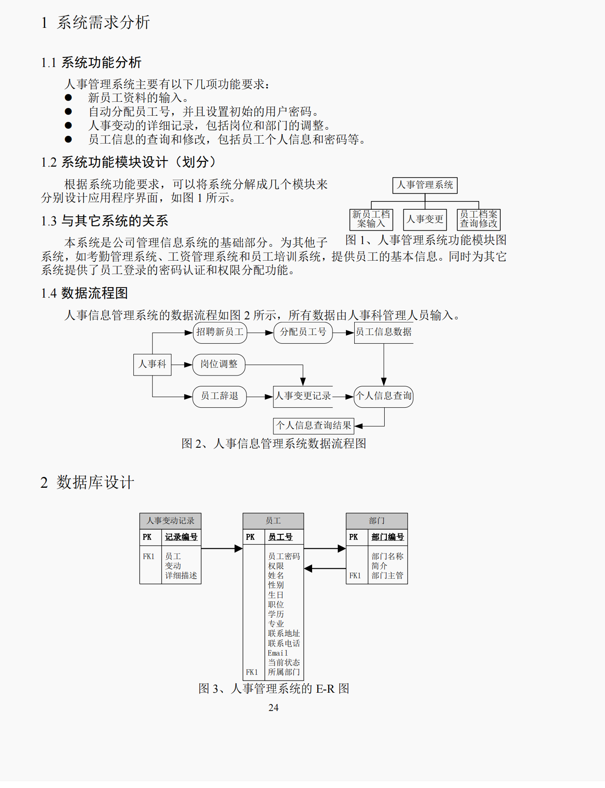

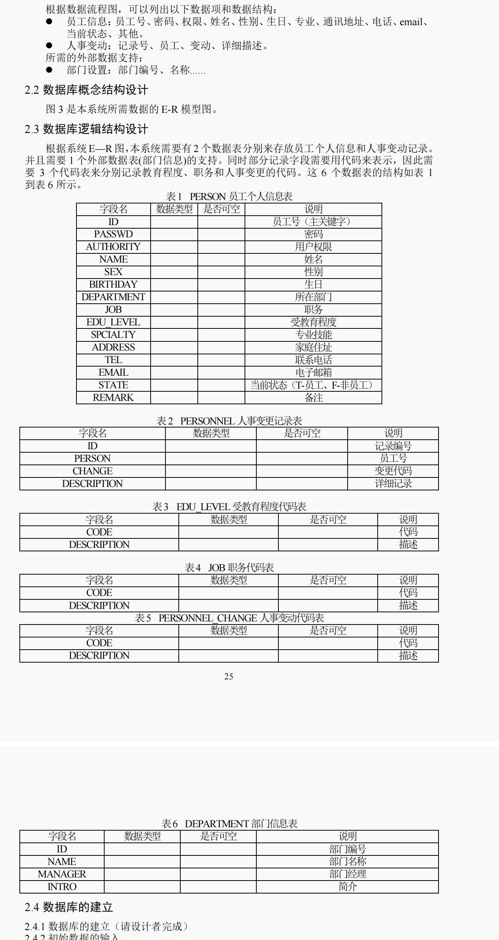

1. 总体设计（含背景知识或基本原理与算法、或模块介绍、设计步骤等）

功能说明

1、增加新员工

2、人事变动

3、员工信息查询修改

4、加密模块

5、员工登录

3.2 用户界面设计

完成数据库创建和功能说明以后，我们可以进行下一步工作，即设计用户界面。我们把

人事信息管理系统的窗体分成____个主要部分，如图____所示。

1. 主窗口的创建

代码如下:采用了网格布局设计

*public static void* admin() {  
 *final* JFrame start = *new* JFrame("人事管理系统");  
 start.setBounds(600, 200, 800, 800);  
 start.setLocationRelativeTo(start.getOwner());  
 start.setVisible(*true*);  
 start.setLayout(*null*);  
 start.setResizable(*false*);  
  
 *final* JTabbedPane tabbedPane = *new* JTabbedPane();  
  
 *//设计首页板块* JPanel panel5 = *new* JPanel(*new* GridLayout(1, 1));  
  
 BackgroundPanel background = *new* BackgroundPanel((*new* ImageIcon("src/img/2.png")).getImage());  
 background.setBorder(*new* EmptyBorder(5, 5, 5, 5));  
 background.setLayout(*null*);  
 background.setSize(800, 800);  
 panel5.add(background);  
 tabbedPane.addTab("首页", panel5);  
  
 *//设计新员工注册板块* JPanel panel1 = *new* JPanel(*new* GridLayout(1, 1));  
 panel1.add(AddStaff.*toAdd*());  
 *//panel1.add(AddStaff.centre9);* tabbedPane.addTab("注册新员工", panel1);  
  
 *//设计人事变动板块* JPanel panel2 = *new* JPanel(*new* GridLayout(1, 1));  
 panel2.add(Chang.*toFind*());  
 tabbedPane.addTab("人事变动查询", panel2);  
  
 *//设计员工信息查询板块* JPanel panel3 = *new* JPanel(*new* GridLayout(1, 1));  
 FindStaff find = *new* FindStaff();  
 panel3.add(find.toFind());  
 tabbedPane.addTab("员工信息查询", panel3);  
  
 *//设计部门  
  
 //设计修改密码板块* JPanel panel4 = *new* JPanel(*new* GridLayout(1, 1));  
 panel4.add(Passwd.*change*());  
 tabbedPane.addTab("修改密码", panel4);  
  
  
 *// 设置默认选中的选项卡* tabbedPane.setSelectedIndex(0);  
  
 start.setContentPane(tabbedPane);  
 start.setVisible(*true*);  
}

效果如图所示: 

1. 增加新员工窗体的创建
2. 主要代码如下: *public static* JComponent toAdd()  
   {  
    *centre* = *new* BackgroundPanel((*new* ImageIcon("src/img/3.png")).getImage());  
    *centre*.setBorder(*new* EmptyBorder(5, 5, 5, 5));  
    *//centre.setLayout(null);  
    centre*.setSize(800, 800);  
     
    *id*.setEditable(*false*);  
    *state*.setEditable(*false*);  
    *Count*=String.*valueOf*(*toCount*()+1);  
    *id*.setText(*Count*);  
    *state*.setText("T");  
    *count*=0;  
     
    *//JPanel center=new JPanel();  
    //center.add(centre);  
    //用一个网状布局表示各个部分  
    centre*.setLayout(*new* GridLayout(9,1,0,0));  
    FlowLayout flow=*new* FlowLayout(FlowLayout.***CENTER***,150,40);  
     
    *//网状布局内部用一个固定布局的面板填充，每个面板又由两个小面板构成* JPanel centre1=*new* JPanel(flow);  
    *//第一行* JPanel cen1=*new* JPanel();  
    *//Id.setFont(Fonts.accounttext);* cen1.add(*Id*);  
    cen1.add(*id*);  
    centre1.add(cen1);  
    JPanel cen2=*new* JPanel();  
    cen2.add(*Name*);  
    cen2.add(*name*);  
    centre1.add(cen2);  
    *//第二行* JPanel centre2=*new* JPanel(flow);  
    JPanel cen3=*new* JPanel();  
    cen3.add(*Sex*);  
    cen3.add(*sex*);  
    JPanel cen4=*new* JPanel();  
    cen4.add(*Age*);  
    cen4.add(*age*);  
    centre2.add(cen3);  
    centre2.add(cen4);  
    *//第三行* JPanel centre3=*new* JPanel(flow);  
    JPanel cen5=*new* JPanel();  
    cen5.add(*Department*);  
    cen5.add(*department*);  
    JPanel cen6=*new* JPanel();  
    cen6.add(*Authority*);  
    cen6.add(*authority*);  
    centre3.add(cen5);  
    centre3.add(cen6);  
    *//第四行* JPanel centre4=*new* JPanel(flow);  
    JPanel cen7=*new* JPanel();  
    cen7.add(*Passwd*);  
    cen7.add(*passwd*);  
    *passwd*.setText("123456");  
    JPanel cen8=*new* JPanel();  
    cen8.add(*Job*);  
    cen8.add(*job*);  
    centre4.add(cen7);  
    centre4.add(cen8);  
    *//第五行* JPanel centre5=*new* JPanel(flow);  
    JPanel cen9=*new* JPanel();  
    cen9.add(*Education*);  
    cen9.add(*education*);  
    JPanel cen10=*new* JPanel();  
    cen10.add(*Spcialty*);  
    cen10.add(*specialty*);  
    centre5.add(cen9);  
    centre5.add(cen10);  
    *//第六行* JPanel centre6=*new* JPanel(flow);  
    JPanel cen11=*new* JPanel();  
    cen11.add(*Address*);  
    cen11.add(*address*);  
    JPanel cen12=*new* JPanel();  
    cen12.add(*Tel*);  
    cen12.add(*tel*);  
    centre6.add(cen11);  
    centre6.add(cen12);  
    *//第七行* JPanel centre7=*new* JPanel(flow);  
    JPanel cen13=*new* JPanel();  
    cen13.add(*Email*);  
    cen13.add(*email*);  
    JPanel cen14=*new* JPanel();  
    cen14.add(*State*);  
    cen14.add(*state*);  
    centre7.add(cen13);  
    centre7.add(cen14);  
    *//第八行* FlowLayout flow2=*new* FlowLayout(FlowLayout.***CENTER***,0,40);  
    JPanel centre8=*new* JPanel(flow2);  
    centre8.add(*Remark*);  
    centre8.add(*remark*);  
    *//第九行* JPanel centre9=*new* JPanel(*new* FlowLayout(FlowLayout.***CENTER***,0,25));  
    JButton botton=*new* JButton("注册");

效果如图所示:

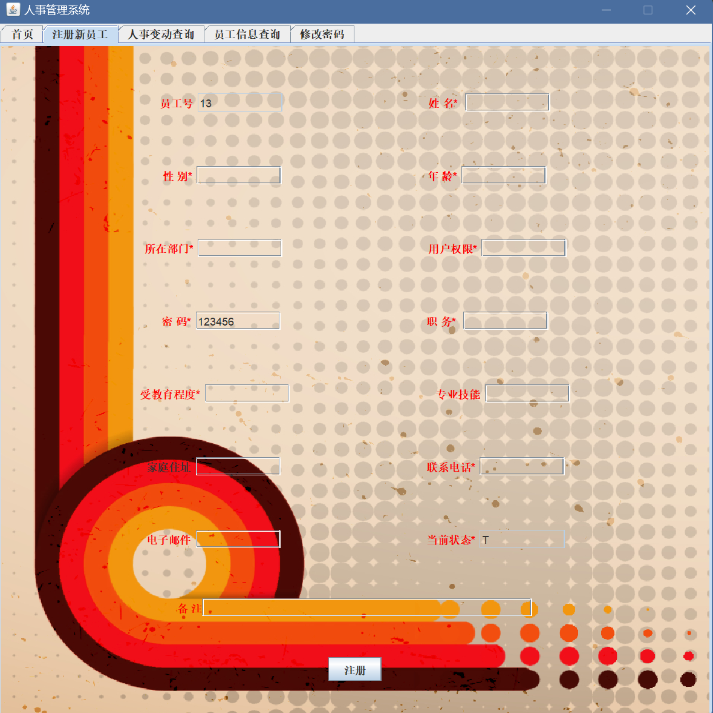

3、人事变动窗体的创建

主要代码如下: *public static* JComponent toFind() {  
 *//JPanel panel=new JPanel();* BackgroundPanel centre = *new* BackgroundPanel((*new* ImageIcon("src/img/3.png")).getImage());  
 centre.setBorder(*new* EmptyBorder(5, 5, 5, 5));  
 *//centre.setLayout(null);* centre.setSize(800, 800);  
 *//centre.add(panel);  
  
 //建立表格  
 staffVector* = *new* Vector();  
 *titleVector* = *new* Vector<>();  
 *titleVector*.add("记录编号");  
 *titleVector*.add("员工号");  
 *titleVector*.add("变更");  
 *titleVector*.add("详细记录");  
 *//studentTableModel = new DefaultTableModel(tableTitle, 15);  
 staffJTable* = *new* MyTable(*staffVector*, *titleVector*);  
 *staffJTable*.getTableHeader().setReorderingAllowed(*false*);  
  
 *staffJTable*.setPreferredScrollableViewportSize(*new* Dimension(740, 340));  
 JScrollPane staffJScrollPane = *new* JScrollPane(*staffJTable*);  
 *//分别设置水平和垂直滚动条自动出现* staffJScrollPane.setHorizontalScrollBarPolicy(  
 JScrollPane.***HORIZONTAL_SCROLLBAR_AS_NEEDED***);  
 staffJScrollPane.setVerticalScrollBarPolicy(  
 JScrollPane.***VERTICAL_SCROLLBAR_AS_NEEDED***);  
 *//staffJTable.setDefaultEditor();  
 //为表格添加监听器  
 staffJTable*.addMouseListener(*new* MouseAdapter() {  
 *public void* mouseClicked(MouseEvent e) {  
 *int* row = ((JTable) e.getSource()).rowAtPoint(e.getPoint()); *// 获得行位置* System.***out***.println("mouseClicked(). row = " + row);  
 Vector v = *new* Vector();  
 v = (Vector) *staffVector*.get(row);  
 *JTnum* = (*int*) v.get(0);  
 }  
 });  
  
 *//设置按键* JButton jSelect = *new* JButton("查询");  
 JButton jSelectAll = *new* JButton("查询所有");  
 JButton jDelete = *new* JButton("删除该记录");  
  
 *//设置下拉框* String[] list = {"记录编号", "员工号", "变更"};  
 JComboBox<String> jCBSelectQueryField = *new* JComboBox<String>(list);*//查询字段* JTextField jSelectFild = *new* JTextField(10);  
  
 centre.setLayout(*null*);  
 JPanel p1 = *new* JPanel(*new* FlowLayout(FlowLayout.***CENTER***));  
 p1.setBounds(10, 20, 750, 400);  
 p1.add(staffJScrollPane);  
 JPanel p3 = *new* JPanel(*null*);  
 p3.setBounds(10, 430, 750, 360);  
 JPanel p2 = *new* JPanel(*new* FlowLayout(FlowLayout.***CENTER***, 30, 40));  
 JPanel p4 = *new* JPanel(*null*);  
 p2.setBounds(0, 0, 750, 100);  
 p4.setBounds(0, 100, 750, 200);  
 *label*.setText("选择查询字段");  
  
 p2.add(jCBSelectQueryField);  
 p2.add(*new* Label("="));  
  
 p2.add(jSelectFild);  
 p2.add(jSelect);  
 p2.add(jSelectAll);  
 p2.add(jDelete);

实现效果如下图: 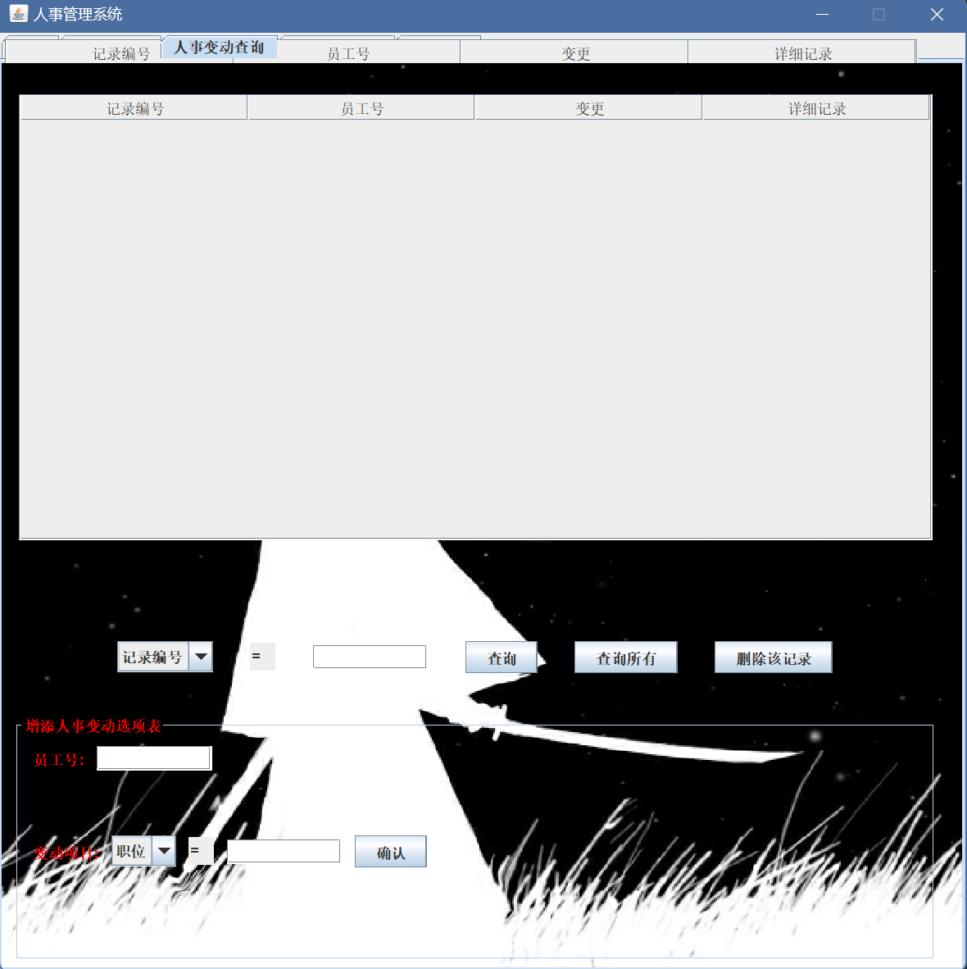

1. 员工信息查询修改窗体的创建

主要代码如下: *start*=*new* JFrame("员工信息");  
*start*.setBounds(600, 200, 800, 800);  
*start*.setLocationRelativeTo(*start*.getOwner());  
*start*.setVisible(*true*);  
*start*.setLayout(*null*);  
*start*.setResizable(*false*);  
  
*centre* = *new* BackgroundPanel((*new* ImageIcon("src/img/5.png")).getImage());  
*centre*.setBorder(*new* EmptyBorder(5, 5, 5, 5));  
*//centre.setLayout(null);  
centre*.setSize(800, 800);  
  
*id*.setEditable(*false*);  
*department*.setEditable(*false*);  
*authority*.setEditable(*false*);  
*job*.setEditable(*false*);  
*passwd*.setEditable(*false*);  
*state*.setEditable(*false*);  
  
  
*queryProcess*(num);  
  
*//JPanel center=new JPanel();  
//center.add(centre);  
//用一个网状布局表示各个部分  
centre*.setLayout(*new* GridLayout(9,1,0,0));  
FlowLayout flow=*new* FlowLayout(FlowLayout.***CENTER***,150,40);  
  
*//网状布局内部用一个固定布局的面板填充，每个面板又由两个小面板构成*JPanel centre1=*new* JPanel(flow);  
*//第一行*JPanel cen1=*new* JPanel();  
*//Id.setFont(Fonts.accounttext);*cen1.add(*Id*);  
cen1.add(*id*);  
centre1.add(cen1);  
JPanel cen2=*new* JPanel();  
cen2.add(*Name*);  
cen2.add(*name*);  
centre1.add(cen2);  
*//第二行*JPanel centre2=*new* JPanel(flow);  
JPanel cen3=*new* JPanel();  
cen3.add(*Sex*);  
cen3.add(*sex*);  
JPanel cen4=*new* JPanel();  
cen4.add(*Age*);  
cen4.add(*age*);  
centre2.add(cen3);  
centre2.add(cen4);  
*//第三行*JPanel centre3=*new* JPanel(flow);  
JPanel cen5=*new* JPanel();  
cen5.add(*Department*);  
cen5.add(*department*);  
JPanel cen6=*new* JPanel();  
cen6.add(*Authority*);  
cen6.add(*authority*);  
centre3.add(cen5);  
centre3.add(cen6);  
*//第四行*JPanel centre4=*new* JPanel(flow);  
JPanel cen7=*new* JPanel();  
cen7.add(*Passwd*);  
cen7.add(*passwd*);  
*//passwd.setText("您不能查看密码");*JPanel cen8=*new* JPanel();  
cen8.add(*Job*);  
cen8.add(*job*);  
centre4.add(cen7);  
centre4.add(cen8);  
*//第五行*JPanel centre5=*new* JPanel(flow);  
JPanel cen9=*new* JPanel();  
cen9.add(*Education*);  
cen9.add(*education*);  
JPanel cen10=*new* JPanel();  
cen10.add(*Specialty*);  
cen10.add(*specialty*);  
centre5.add(cen9);  
centre5.add(cen10);  
*//第六行*JPanel centre6=*new* JPanel(flow);  
JPanel cen11=*new* JPanel();  
cen11.add(*Address*);  
cen11.add(*address*);  
JPanel cen12=*new* JPanel();  
cen12.add(*Tel*);  
cen12.add(*tel*);  
centre6.add(cen11);  
centre6.add(cen12);  
*//第七行*JPanel centre7=*new* JPanel(flow);  
JPanel cen13=*new* JPanel();  
cen13.add(*Email*);  
cen13.add(*email*);  
JPanel cen14=*new* JPanel();  
cen14.add(*State*);  
cen14.add(*state*);  
centre7.add(cen13);  
centre7.add(cen14);  
*//第八行*FlowLayout flow2=*new* FlowLayout(FlowLayout.***CENTER***,0,40);  
JPanel centre8=*new* JPanel(flow2);  
centre8.add(*Remark*);  
centre8.add(*remark*);  
*//第九行*JPanel centre9=*new* JPanel(*new* FlowLayout(FlowLayout.***CENTER***,0,25));  
JButton botton=*new* JButton("修改");  
  
botton.addActionListener(e->{  
 *updateProcess*();  
});  
botton.setOpaque(*false*);  
*//botton.setSize(60,40);*centre9.add(botton);  
  
*//center.setOpaque(false);  
centre*.setOpaque(*false*);  
centre1.setOpaque(*false*);  
centre2.setOpaque(*false*);  
centre3.setOpaque(*false*);  
centre4.setOpaque(*false*);  
centre5.setOpaque(*false*);  
centre6.setOpaque(*false*);  
centre7.setOpaque(*false*);  
centre8.setOpaque(*false*);  
centre9.setOpaque(*false*);  
cen1.setOpaque(*false*);  
cen2.setOpaque(*false*);  
cen3.setOpaque(*false*);  
cen4.setOpaque(*false*);  
cen5.setOpaque(*false*);  
cen6.setOpaque(*false*);  
cen7.setOpaque(*false*);  
cen8.setOpaque(*false*);  
cen9.setOpaque(*false*);  
cen10.setOpaque(*false*);  
cen11.setOpaque(*false*);  
cen12.setOpaque(*false*);  
cen13.setOpaque(*false*);  
cen14.setOpaque(*false*);  
*id*.setOpaque(*false*);  
*passwd*.setOpaque(*false*);  
*authority*.setOpaque(*false*);  
*name*.setOpaque(*false*);  
*sex*.setOpaque(*false*);  
*age*.setOpaque(*false*);  
*department*.setOpaque(*false*);  
*job*.setOpaque(*false*);  
*education*.setOpaque(*false*);  
*specialty*.setOpaque(*false*);  
*address*.setOpaque(*false*);  
*tel*.setOpaque(*false*);  
*email*.setOpaque(*false*);  
*state*.setOpaque(*false*);  
*remark*.setOpaque(*false*);  
  
  
*//center.add(centre9);  
centre*.add(centre1);  
*centre*.add(centre2);  
*centre*.add(centre3);  
*centre*.add(centre4);  
*centre*.add(centre5);  
*centre*.add(centre6);  
*centre*.add(centre7);  
*centre*.add(centre8);  
*centre*.add(centre9);  
  
*start*.add(*centre*);

效果如图所示: 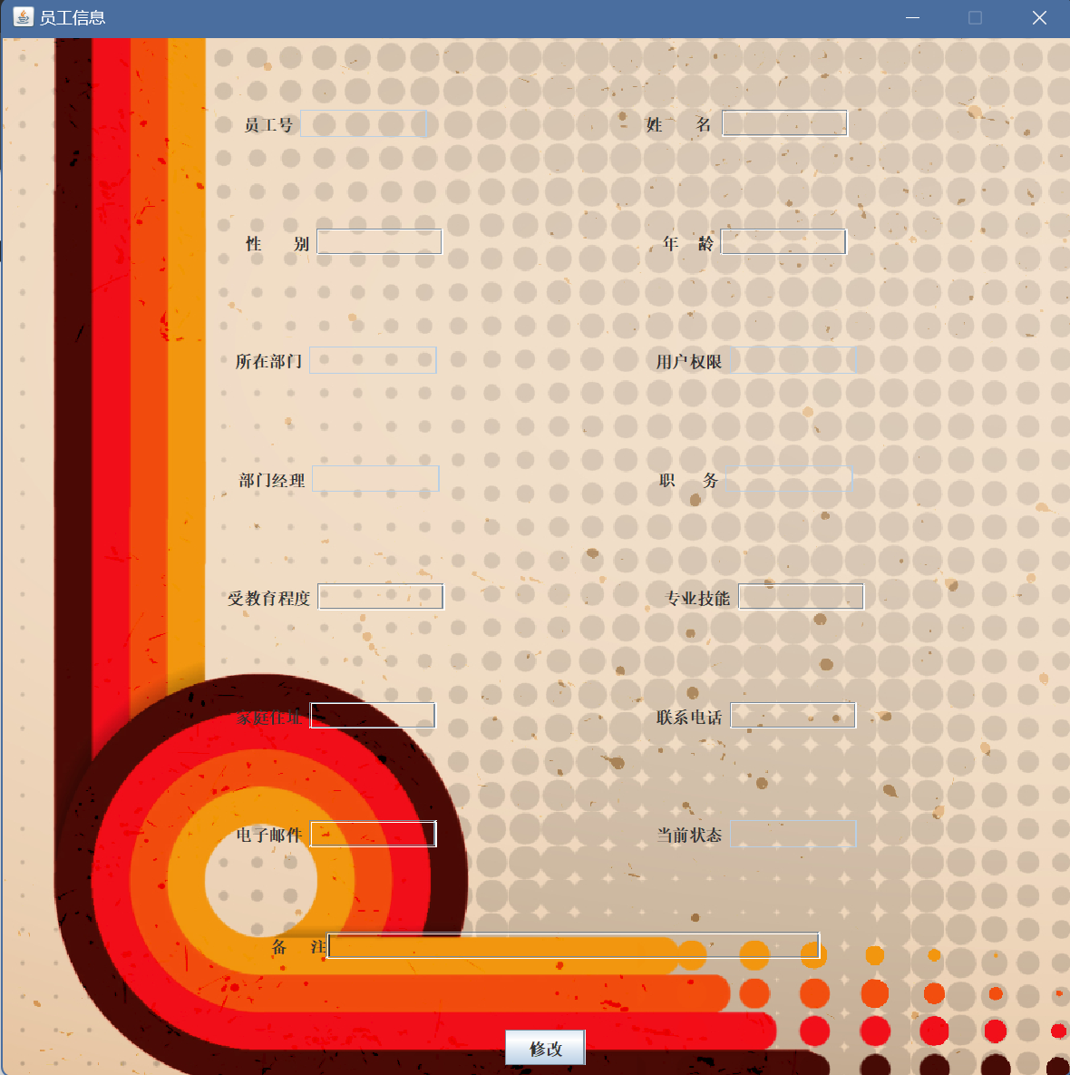

1. 加密模块的创建

使用了存储哈希值方法,代码如下: *public static void* storeHash(String s, String hashString) {  
 *if* (s == *null* || hashString == *null*) {  
 System.***out***.println("Error: One or both strings are null");  
 *return*;  
 }  
  
 *if* (s.length() == 0 || hashString.length() == 0) {  
 System.***out***.println("Error: One or both strings are empty");  
 *return*;  
 }  
  
 MessageDigest md = MessageDigest.*getInstance*("SHA-256");  
 *byte*[] hashInBytes = md.digest(s.getBytes(StandardCharsets.***UTF_8***));  
 String hashString2 = String.valueOf(hashInBytes, StandardCharsets.***UTF_8***);  
  
 *if* (hashString2.equals(hashString)) {  
 System.***out***.println("Hash values match");  
 } *else* {  
 System.***out***.println("Error: Hash values do not match");  
 }  
}  
*public static* String decrypt(String hashString) {  
 *if* (hashString == *null*)  
 *return* "";  
 *if* (hashString.length() == 0)  
 *return* "";  
  
 MessageDigest md = MessageDigest.*getInstance*("SHA-256");  
 *byte*[] hashInBytes = hashString.getBytes(StandardCharsets.***UTF_8***);  
 *byte*[] decryptedBytes = md.digest(hashInBytes);  
 String decryptedString = *new* String(decryptedBytes, StandardCharsets.***UTF_8***);  
  
 *return* decryptedString;  
}

}

1. 登录窗口的创建

主要代码如下: *void* init(){  
  
 *//初始化面板1（标题）* jpanel_1 = *new* javax.swing.JPanel();  
 jpanel_1.setBounds(0,0,WIDTH,HEIGHT);  
 jpanel_1.setLayout(*null*);  
 *//初始化面板2（账号）* jpanel_2 = *new* javax.swing.JPanel();  
 jpanel_2.setBounds(0,50,WIDTH,50);  
 flowLayout=*new* FlowLayout(FlowLayout.***CENTER***);*//居中对齐* jpanel_2.setLayout(flowLayout);  
 jpanel_2.setOpaque(*false*);  
 *//初始化面板3（密码）* jpanel_3 = *new* javax.swing.JPanel();  
 jpanel_3.setBounds(80,100,310,200);  
 flowLayout=*new* FlowLayout(FlowLayout.***CENTER***);*//居中对齐* jpanel_3.setLayout(flowLayout);  
 jpanel_3.setOpaque(*false*);  
 *//初始化面板4（登录）* jpanel_4 = *new* javax.swing.JPanel();  
 jpanel_4.setBounds(100,170,300,70);  
 flowLayout=*new* FlowLayout(FlowLayout.***CENTER***);*//居中对齐* jpanel_4.setLayout(flowLayout);  
 jpanel_4.setOpaque(*false*);  
  
 *//初始化字体类* Fonts fonts= *new* Fonts();  
  
  
 *//载入背景图片等信息* ImageIcon img= *new* ImageIcon("src/img/wallhaven-md1yry.jpg");  
 bgimg=*new* JLabel(img);  
 bgimg.setBounds(0,0,img.getIconWidth(),img.getIconHeight());  
  
 title=*new* JLabel("人事管理系统");  
 title.setFont(Fonts.*title*);  
 title.setForeground(*new* Color(255,228,181));  
  
 account=*new* JLabel("账号");  
 account.setFont(Fonts.*account*);  
 account.setForeground(*new* Color(255,228,181));  
  
 accounttext= *new* JTextField(15);  
 accounttext.setFont(Fonts.*account*);  
 accounttext.setForeground(Color.***BLACK***);  
  
 password=*new* JLabel("密码");  
 password.setFont(Fonts.*account*);  
 password.setForeground(*new* Color(255,228,181));  
  
 passwordtext= *new* JPasswordField(15);  
 passwordtext.setFont(Fonts.*account*);  
 passwordtext.setForeground(Color.***BLACK***);  
  
 ok=*new* JButton("登录");  
 ok.setPreferredSize(*new* Dimension(250,50));  
 ok.setFont(Fonts.*ok*);  
 ok.setForeground(Color.***BLACK***);  
 ok.setBackground(*new* Color(255,255,255));  
  
 register=*new* JButton(("注册账号"));  
 register.setPreferredSize(*new* Dimension(120,50));  
 register.setFont(Fonts.*ok*);  
 register.setForeground(Color.***BLACK***);  
 register.setBackground(*new* Color(8,189,252));  
  
 state=*new* JLabel("忘记密码？");  
 state.setFont(Fonts.*state*);  
 state.setForeground(*new* Color(255,228,181));  
 state.setBounds(0,230,100,100);*//注意* jpanel_3.add(account);  
 jpanel_3.add(accounttext);  
 jpanel_3.add(password);  
 jpanel_3.add(passwordtext);  
 *//jpanel_4.add(register);* jpanel_4.add(ok);  
 jpanel_2.add(title);  
 jpanel_1.add(jpanel_2);  
 jpanel_1.add(jpanel_3);  
 jpanel_1.add(jpanel_4);  
 jpanel_1.add(state);  
 jpanel_1.add(bgimg);  
  
 ***Login***.add(jpanel_2);  
 ***Login***.add(jpanel_1);

效果如图所示: 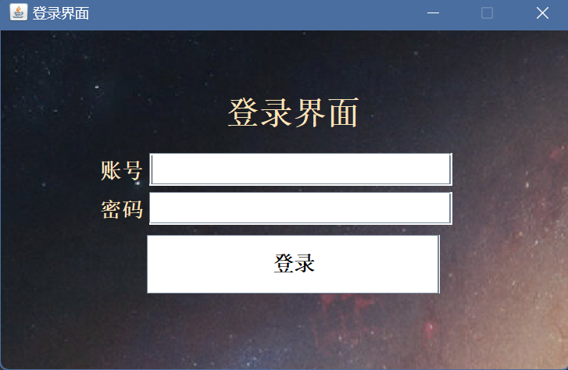

输入正确的账号密码会进入管理系统,但输入错误的密码会提示错误信息

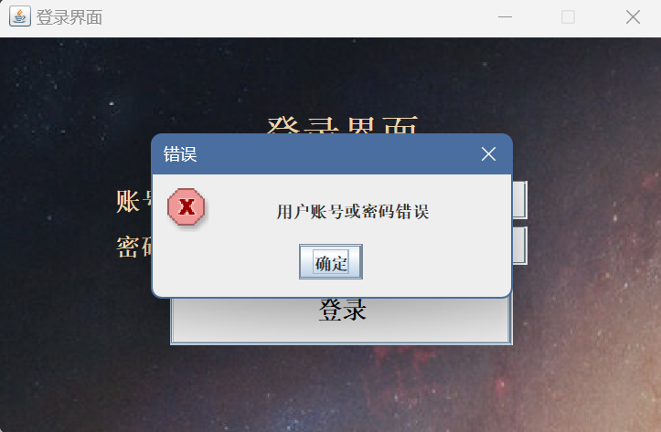

四、详细设计（含主要的数据结构、程序流程图、关键代码等）

各功能模块的实现

1. 增加新员工的实现

主要代码如下: botton.addActionListener(e->{  
 *if*(!*name*.getText().isEmpty()&&!*sex*.getText().isEmpty()&&!*department*.getText().isEmpty()&&!*authority*.getText().isEmpty()&&!*job*.getText().isEmpty()&&!*education*.getText().isEmpty()&&!*tel*.getText().isEmpty()&&!*passwd*.getText().isEmpty()&&!*state*.getText().isEmpty()&&!*age*.getText().isEmpty())  
 {  
 String sId = *id*.getText().trim();  
 String sName = *name*.getText().trim();  
 String sPasswd = MD5.*encrypt*(*passwd*.getText().trim());  
 String sSex = *sex*.getText().trim();  
  
 String sAge = *age*.getText().trim();  
 String sSpecialty = *specialty*.getText().trim();  
 String sAddress = *address*.getText().trim();  
 String sAuthority = *authority*.getText().trim();  
 String sDepartment = *department*.getText().trim();  
 String sJob = *job*.getText().trim();  
 String sEducation = *education*.getText().trim();  
 String sTel = *tel*.getText().trim();  
 String sEmail = *email*.getText().trim();  
 String sState = *state*.getText().trim();  
 String sRemark = *remark*.getText().trim();  
  
 *// 建立插入条件* String sql = "insert into person values(";  
 sql = sql + sId ;  
 sql = sql +",'" + sPasswd+"'";  
 sql = sql + ",'" + sName+"'";  
 sql = sql +",'" + sSex+"'" ;  
 sql = sql +"," + sAge ;  
 sql = sql +",'" + sAuthority+"'" ;  
 sql = sql +",'" + sDepartment+"'" ;  
 sql = sql +",'" + sJob +"'";  
 sql =sql +",'" + sEducation+"'" ;  
 *if*(sAddress.isEmpty())sql= sql+",null";  
 *else* sql =sql +",'" + sAddress+"'" ;  
 *if*(sSpecialty.isEmpty())sql= sql+",null";  
 *else* sql =sql +",'" + sSpecialty +"'";  
 sql = sql +",'" + sTel +"'";  
 *if*(sEmail.isEmpty())sql= sql+",null";  
 *else* sql = sql +",'" + sEmail +"'";  
 sql =sql + ",'" + sState+"'";  
 *if*(sRemark.isEmpty())sql= sql+",null"+");";  
 *else* sql = sql +",'" + sRemark+"');";  
  
 System.***out***.println("insertProcess(). sql = " + sql);  
 *try*{  
 *if* (DbProcess.*executeUpdate*(sql) < 1) {  
 System.***out***.println("insertProcess(). insert database failed.");  
 }  
 *else*{  
 System.***out***.println("insertProcess(). insert successful.");  
 JOptionPane.*showMessageDialog*(*null*,  
 "新员工注册成功","成功",JOptionPane.***INFORMATION_MESSAGE***);  
 Chang.*upDataProcess*("insert into personnel value("+(Chang.*toCount*()+1)+",'"+*id*.getText().trim()+"',0,'部门"+*department*.getText().trim()+*job*.getText().trim()+"');");  
 *Count*=String.*valueOf*(*toCount*()+1);  
 *id*.setText(*Count*);  
 *count*=0;  
 *name*.setText("");  
 *sex*.setText("");  
 *age*.setText("");  
 *department*.setText("");  
 *authority*.setText("");  
 *passwd*.setText("123456");  
 *job*.setText("");  
 *education*.setText("");  
 *specialty*.setText("");  
 *tel*.setText("");  
 *state*.setText("");  
 *email*.setText("");  
 *remark*.setText("");  
 *address*.setText("");  
 }  
 }*catch*(Exception even){  
 System.***out***.println("e = " + even);  
 JOptionPane.*showMessageDialog*(*null*,  
 "数据操作错误","错误",JOptionPane.***ERROR_MESSAGE***);  
 }  
 }*else*{  
 *//System.out.println(name.getText()+sex.getText()+department.getText()+authority.getText()+job.getText()+education.getText().isEmpty()&&+tel.getText());* System.***out***.println("注册失败:未填写所有带*的信息");  
 JOptionPane.*showMessageDialog*(*null*,  
 "请填写所有带*的信息","错误",JOptionPane.***ERROR_MESSAGE***);  
 }

完成结果如下:

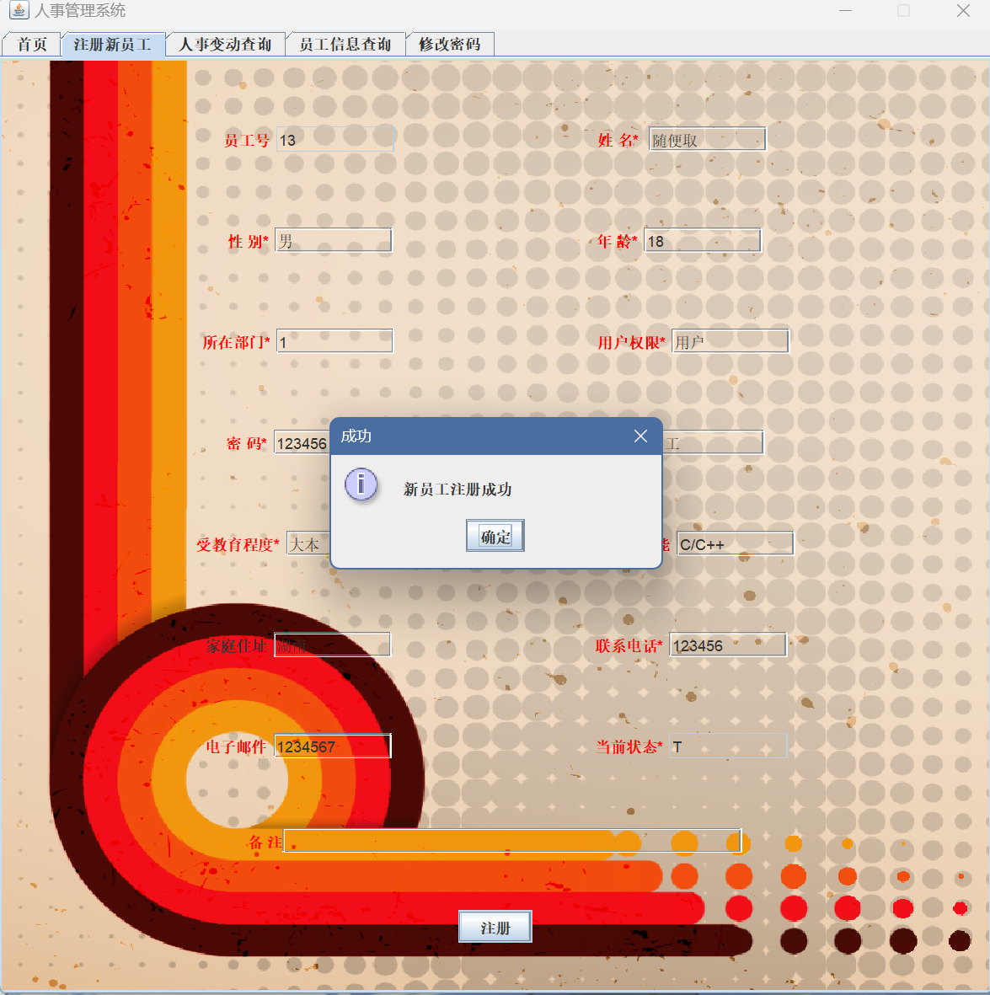

1. 人事变动的实现

主要代码如下: upData.addActionListener(e -> {  
 String sql = "insert into personnel value(";  
 String sql2 = "update person set ";  
 String NAME = *selectOneProcess*("select name from person where id=" + *id*.getText().trim() + ";");  
 String NUM = *selectOneProcess*("select department from person where id=" + *id*.getText().trim() + ";");  
 String sql3 = "";  
 sql += (*toCount*() + 1) + "," + *id*.getText().trim() + ",";  
 *switch* ((String) *jCBSelectQueryField2*.getSelectedItem()) {  
 *case* "职位":  
 sql += 1 + ",'" + *jSelectFild2*.getText().trim() + "');";  
 sql2 += " job='" + *jSelectFild2*.getText().trim() + "'";  
 *if* (*jSelectFild2*.getText().trim().equals("经理")) {  
 sql3 = "update depart set manager='" + NAME + "' where id=" + NUM + ";";  
 } *else* {  
 sql3 = "update depart set manager=null where id=" + NUM + ";";  
 }  
 *upDataDepertProcess*(sql3);  
 *break*;  
 *case* "部门":  
 sql += 2 + ",'部门" + *jSelectFild2*.getText().trim() + "');";  
 sql2 += " department=" + *jSelectFild2*.getText().trim() + "";  
 *break*;  
 *case* "辞退":  
 sql += 3 + ",'辞退" + *jSelectFild2*.getText().trim() + "');";  
 sql2 += " state='F' ";  
 *break*;  
 }  
 sql2 += " where id=" + *id*.getText().trim() + ";";  
 *upDataProcess*(sql);  
 *upDataPersonProcess*(sql2);

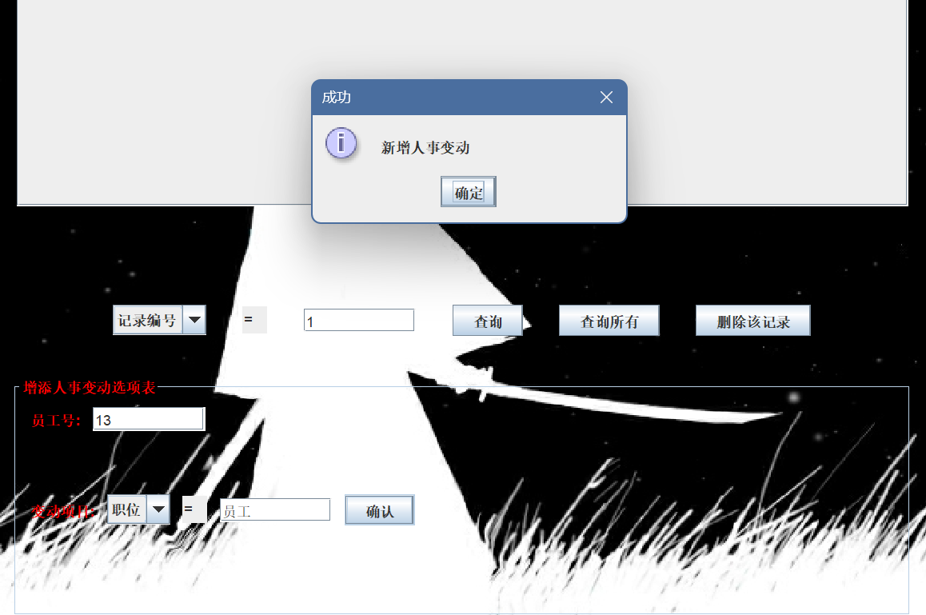

1. 员工信息查询修改的实现

实现效果如下:

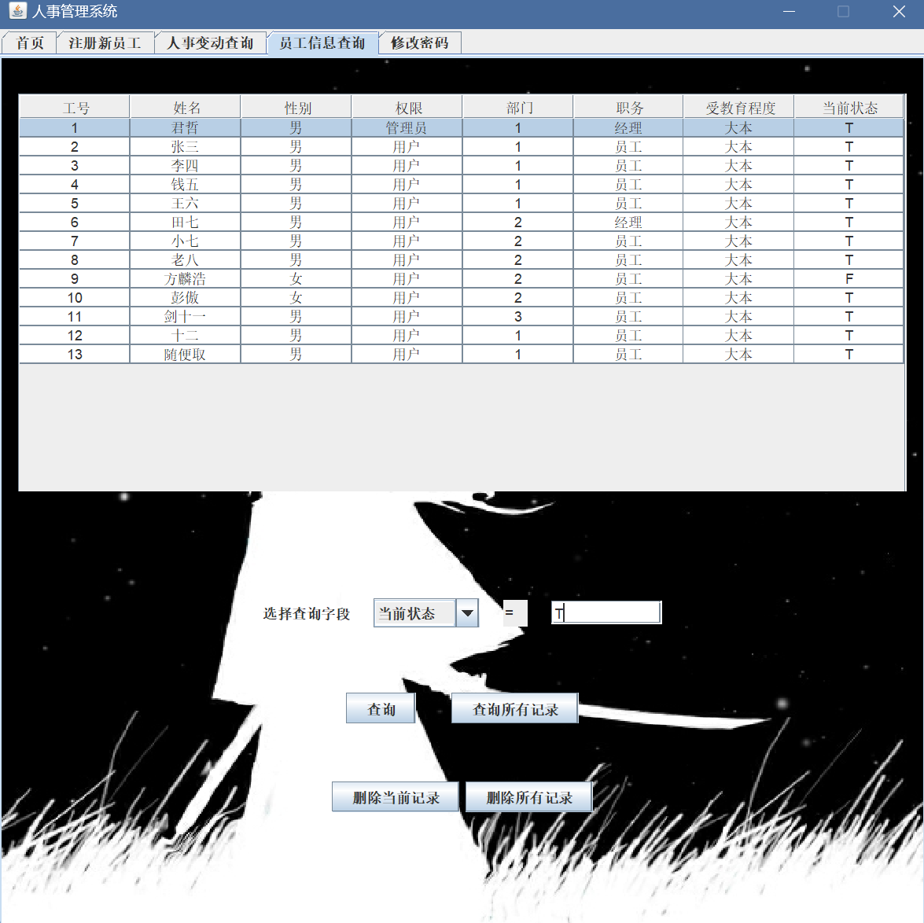

也可以选择查询字段: 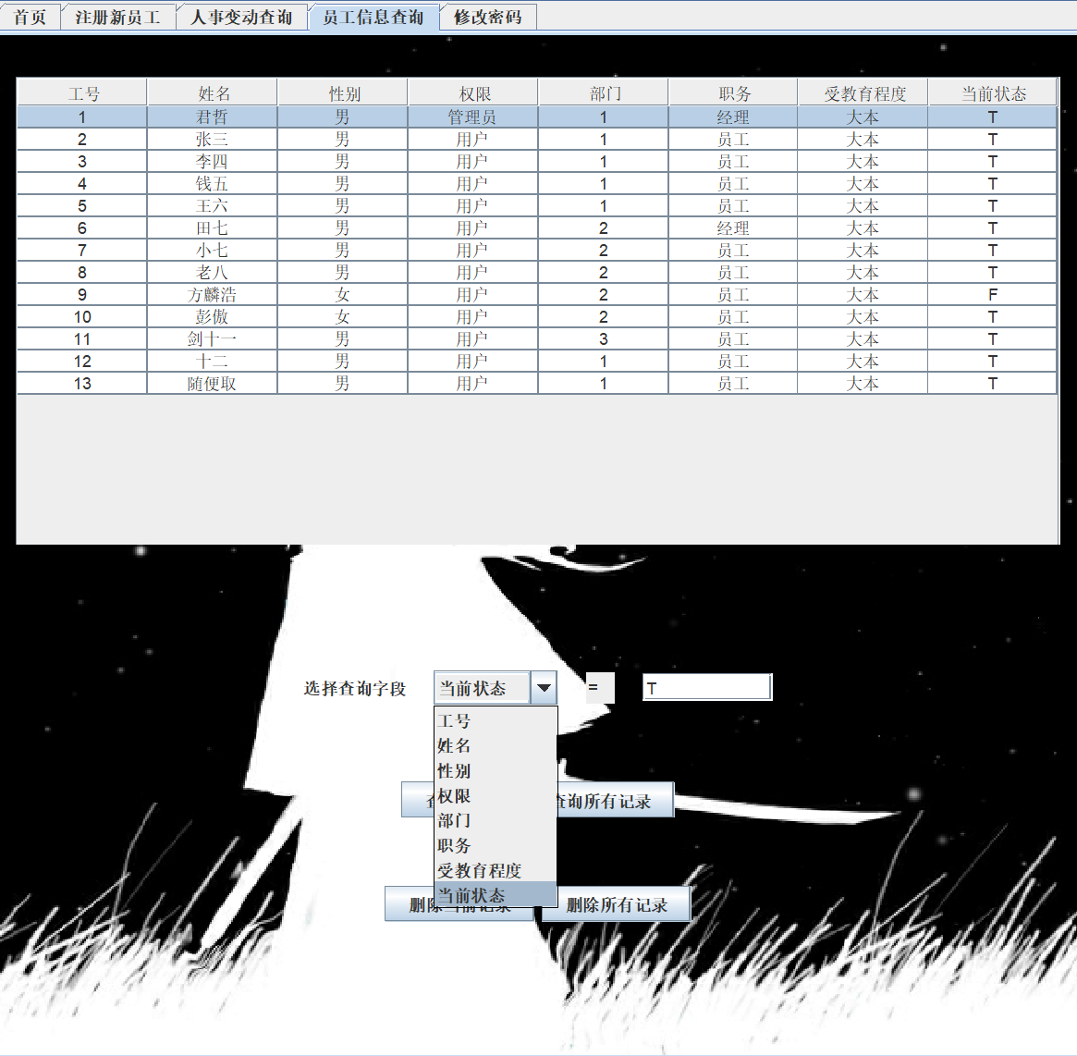

当前选择为当前状态T的成员: 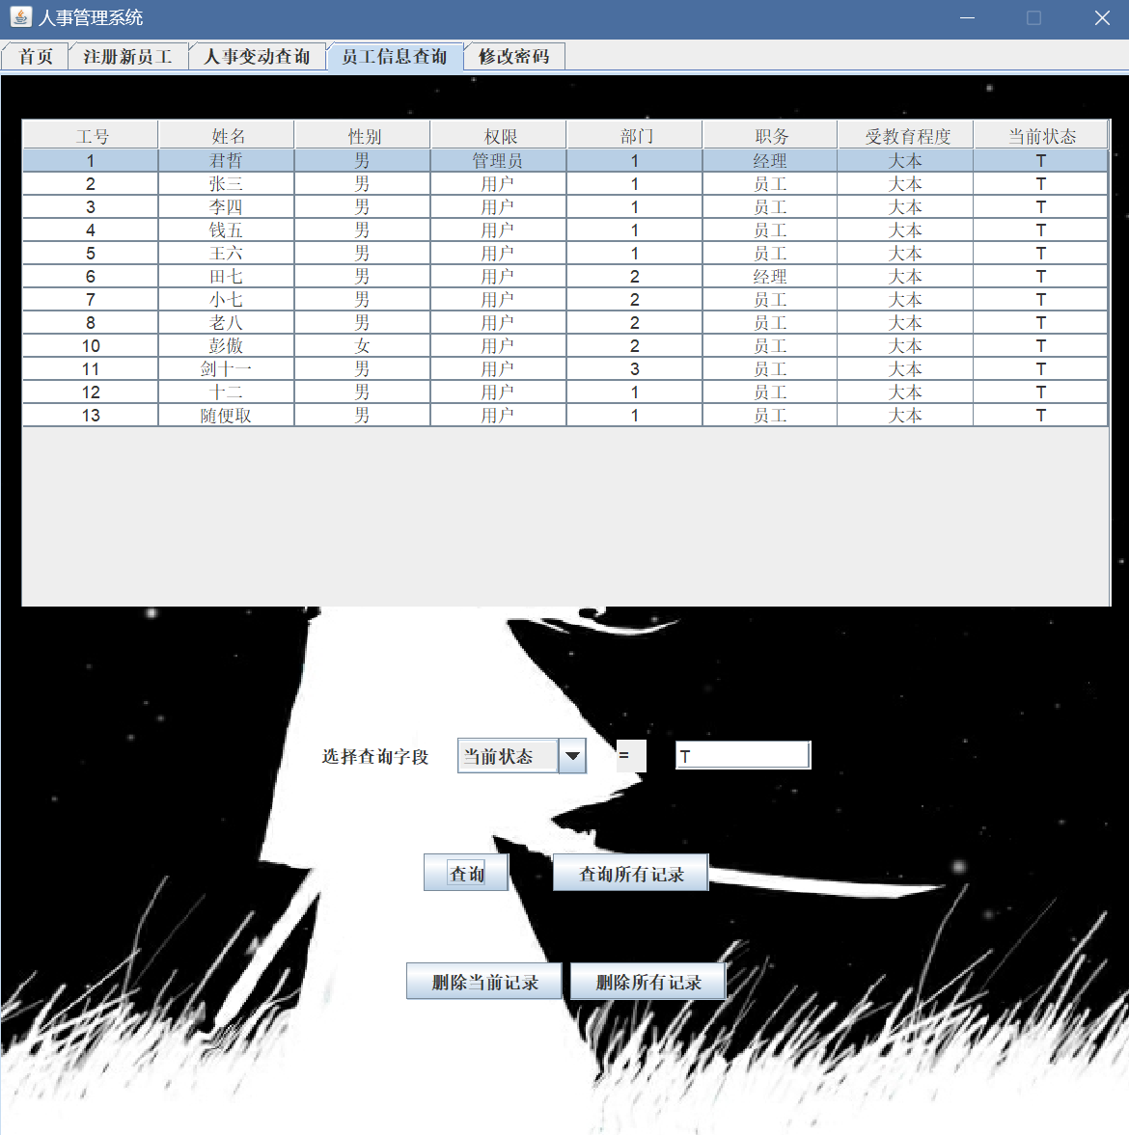

查询效果的主要代码如下: *public void* queryProcess(String sQueryField)  
{  
 *try*{  
 *// 建立查询条件* String sql = "select * from person where ";  
 String queryFieldStr = jCBSelectQueryFieldTransfer(*SelectQueryFieldStr*);  
  
 *if*(queryFieldStr.equals("age")||queryFieldStr.equals("id")){*//int sAge.* sql = sql + queryFieldStr;  
 sql = sql + " = " + sQueryField;  
 }*else*{  
 sql = sql + queryFieldStr;  
 sql = sql + " = ";  
 sql = sql + "'" + sQueryField + "'";  
 }  
 sql+=" order by id asc;";  
  
 System.***out***.println("queryProcess(). sql = " + sql);  
  
 DbProcess.*connect*();  
 *ResultSet* rs = DbProcess.*executeQuery*(sql);  
  
 *// 将查询获得的记录数据，转换成适合生成JTable的数据形式  
 staffVector*.clear();  
 *while*(rs.next()){  
 Vector v = *new* Vector();  
 v.add(Integer.*valueOf*(rs.getInt("id")));  
 v.add(rs.getString("name"));  
 v.add(rs.getString("sex"));  
 v.add(rs.getString("authority"));  
 v.add(rs.getString("department"));  
 v.add(rs.getString("job"));  
 v.add(rs.getString("education"));  
 v.add(rs.getString("state"));  
 *staffVector*.add(v);  
 }  
  
 *staffJTable*.updateUI();  
  
 DbProcess.*disconnect*();  
 }*catch*(SQLException sqle){  
 System.***out***.println("sqle = " + sqle);  
 JOptionPane.*showMessageDialog*(*null*,  
 "数据操作错误","错误",JOptionPane.***ERROR_MESSAGE***);  
 }*catch*(Exception e){  
 System.***out***.println("e = " + e);  
 JOptionPane.*showMessageDialog*(*null*,  
 "数据操作错误","错误",JOptionPane.***ERROR_MESSAGE***);  
 }  
}  
  
*public void* queryAllProcess()  
{  
 *try*{  
 *// 建立查询条件* String sql = "select * from person ";  
 sql+=" order by id asc;";  
 System.***out***.println("queryAllProcess(). sql = " + sql);  
  
 DbProcess.*connect*();  
 *ResultSet* rs = DbProcess.*executeQuery*(sql);  
  
 *// 将查询获得的记录数据，转换成适合生成JTable的数据形式  
 staffVector*.clear();  
 *while*(rs.next()){  
 Vector v = *new* Vector();  
 v.add(Integer.*valueOf*(rs.getInt("id")));  
 v.add(rs.getString("name"));  
 v.add(rs.getString("sex"));  
 v.add(rs.getString("authority"));  
 v.add(rs.getString("department"));  
 v.add(rs.getString("job"));  
 v.add(rs.getString("education"));  
 v.add(rs.getString("state"));  
 *staffVector*.add(v);  
 }  
 *staffJTable*.updateUI();  
 DbProcess.*disconnect*();  
 }*catch*(SQLException sqle){  
 System.***out***.println("sqle = " + sqle);  
 JOptionPane.*showMessageDialog*(*null*,  
 "数据操作错误","错误",JOptionPane.***ERROR_MESSAGE***);  
 }  
}

修改列表如下: 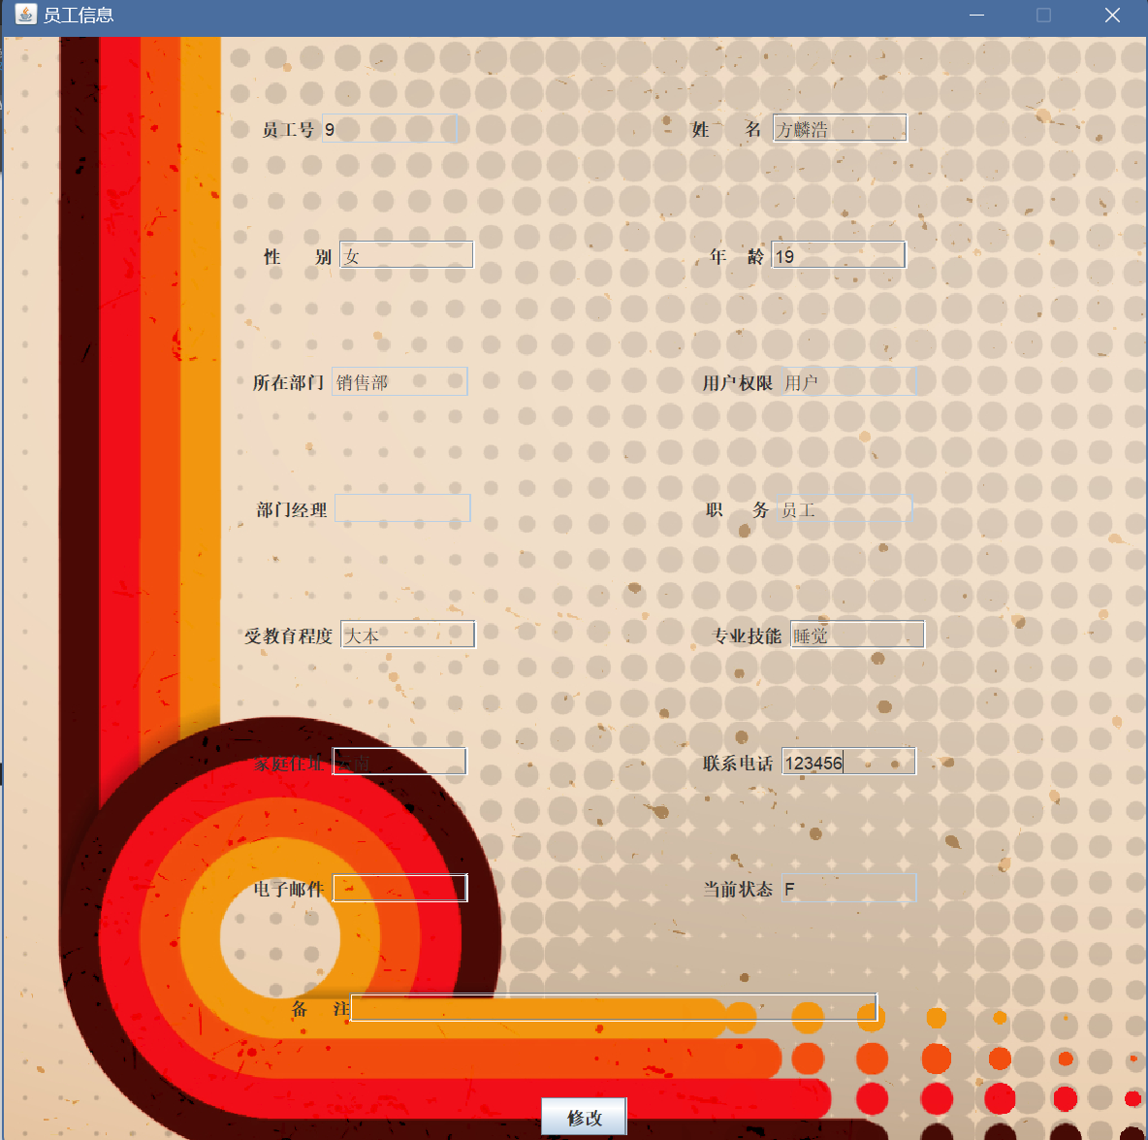

修改后显示: 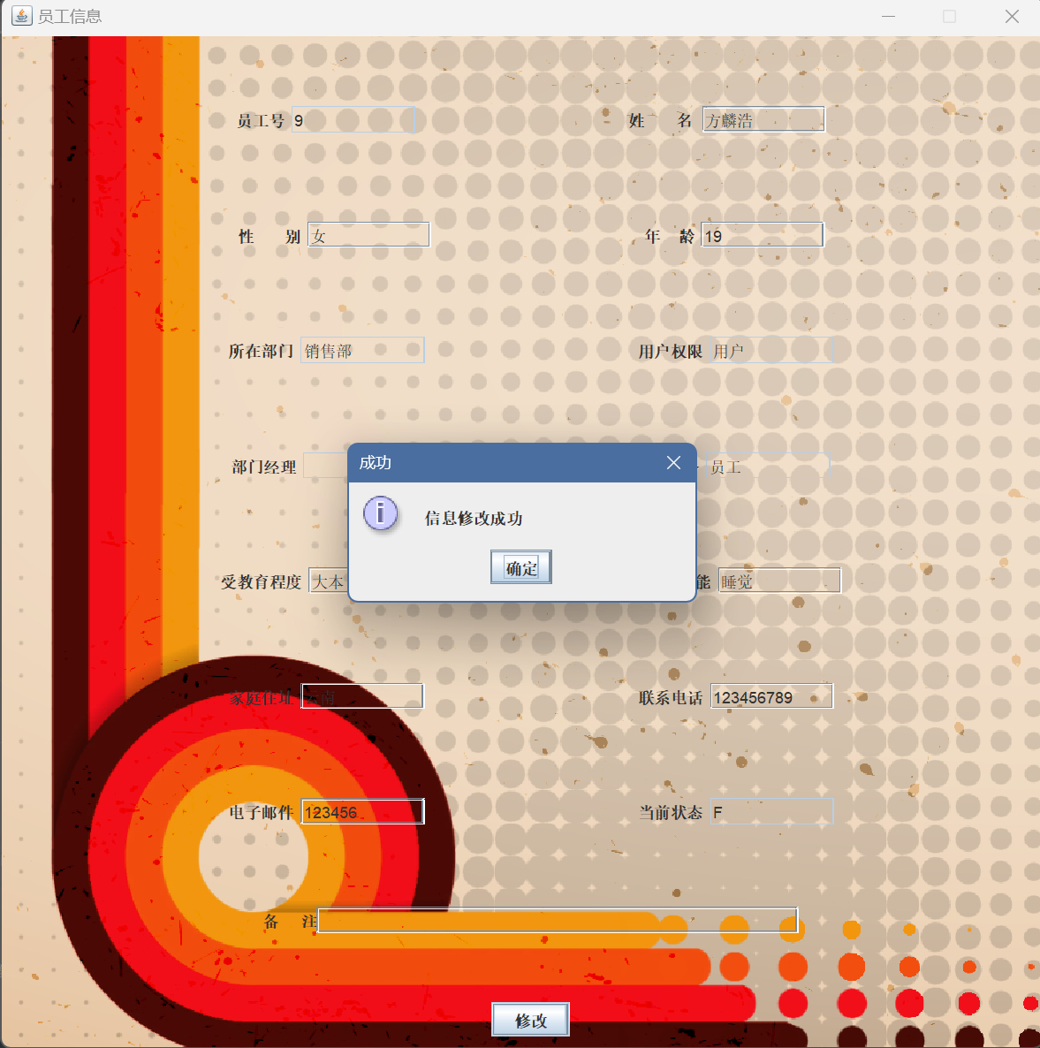

修改效果的主要代码如下: *public static void* updateProcess() {  
  
 *if* (!*name*.getText().isEmpty() && !*sex*.getText().isEmpty() && !*department*.getText().isEmpty() && !*authority*.getText().isEmpty() && !*job*.getText().isEmpty() && !*education*.getText().isEmpty() && !*tel*.getText().isEmpty() && !*passwd*.getText().isEmpty() && !*state*.getText().isEmpty() && !*age*.getText().isEmpty()) {  
 String sId = *id*.getText().trim();  
 String sName = *name*.getText().trim();  
 *//String sPasswd = passwd.getText().trim();* String sSex = *sex*.getText().trim();  
  
 String sAge = *age*.getText().trim();  
 String sSpecialty = *specialty*.getText().trim();  
 String sAddress = *address*.getText().trim();  
  
 String sTel = *tel*.getText().trim();  
 String sEmail = *email*.getText().trim();  
 *//String sState = state.getText().trim();* String sRemark = *remark*.getText().trim();  
  
 *// 建立更新条件* String sql = "update person set name = '";  
 sql = sql + sName + "', sex = '";  
 sql = sql + sSex + "', age = ";  
 sql = sql + sAge + ", specialty = '";  
 sql = sql + sSpecialty + "', address = '";  
 sql = sql + sAddress + "',tel='";  
 sql = sql + sTel + "',email='";  
 sql = sql + sEmail + "',remark='";  
 sql = sql + sRemark + "'";  
 sql = sql + " WHERE id = " + sId + ";";  
 System.***out***.println("updateProcess(). sql = " + sql);  
 *try* {  
 *if* (DbProcess.*executeUpdate*(sql) < 1) {  
 System.***out***.println("updateProcess(). update database failed.");  
 } *else* {  
 JOptionPane.*showMessageDialog*(*null*,  
 "信息修改成功", "成功", JOptionPane.***INFORMATION_MESSAGE***);  
 *//start.setVisible(false);* System.***out***.println("updateProcess(). update database successful.");  
 }  
 } *catch* (Exception e) {  
 System.***out***.println("e = " + e);  
 JOptionPane.*showMessageDialog*(*null*,  
 "数据操作错误", "错误", JOptionPane.***ERROR_MESSAGE***);  
 }  
 *//queryAllProcess();* } *else* {  
  
 System.***out***.println("修改失败:未填写所有带 * 号的信息");  
 JOptionPane.*showMessageDialog*(*null*,  
 "请填写所有带 * 号的信息", "错误", JOptionPane.***ERROR_MESSAGE***);  
 }  
}

1. 加密模块的实现

使用了存储哈希值方法:主要实现如下

*public static void* storeHash(String s, String hashString) {  
 *if* (s == *null* || hashString == *null*) {  
 System.***out***.println("Error: One or both strings are null");  
 *return*;  
 }  
  
 *if* (s.length() == 0 || hashString.length() == 0) {  
 System.***out***.println("Error: One or both strings are empty");  
 *return*;  
 }  
  
 MessageDigest md = MessageDigest.*getInstance*("SHA-256");  
 *byte*[] hashInBytes = md.digest(s.getBytes(StandardCharsets.***UTF_8***));  
 String hashString2 = String.valueOf(hashInBytes, StandardCharsets.***UTF_8***);  
  
 *if* (hashString2.equals(hashString)) {  
 System.***out***.println("Hash values match");  
 } *else* {  
 System.***out***.println("Error: Hash values do not match");  
 }  
}  
*public static* String decrypt(String hashString) {  
 *if* (hashString == *null*)  
 *return* "";  
 *if* (hashString.length() == 0)  
 *return* "";  
  
 MessageDigest md = MessageDigest.*getInstance*("SHA-256");  
 *byte*[] hashInBytes = hashString.getBytes(StandardCharsets.***UTF_8***);  
 *byte*[] decryptedBytes = md.digest(hashInBytes);  
 String decryptedString = *new* String(decryptedBytes, StandardCharsets.***UTF_8***);  
  
 *return* decryptedString;  
}

1. 员工登录的实现

登录界面如图所示:

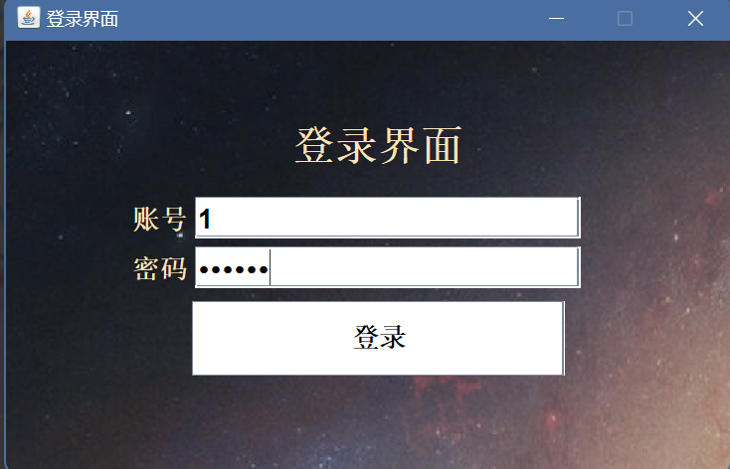

输入正确的账号密码后进入管理系统首页: 

输入错误的账号密码会提示错误



代码实现如下: *public* LoginStart()  
{  
 *//Start.admin();  
 //Start.admin();  
 //设置窗口大小* ***Login***.setBounds(600, 200, WIDTH, HEIGHT);  
 ***Login***.setLocationRelativeTo(***Login***.getOwner());  
 init();  
 ***Login***.setVisible(*true*);  
 ***Login***.setResizable(*false*);  
  
  
 ok.addMouseListener(*new* MouseAdapter(){ *//加入监听器  
 public void* mouseClicked(MouseEvent e){  
 *ver*=*verification*(accounttext.getText(),passwordtext.getText());  
 System.***out***.println(accounttext.getText());  
 System.***out***.println(passwordtext.getText());  
  
 *//System.out.println(ver);  
 if*(*ver*==2){  
 System.***out***.println("登录成功");  
 ***Login***.setVisible(*false*);  
 *//Start.account();* Account.*start*(Integer.*parseInt*(accounttext.getText()));  
 }  
 *else if*(*ver*==1)  
 {  
 System.***out***.println("登录成功");  
 ***Login***.setVisible(*false*);  
 Start.*admin*();  
 *//choice.choose();* }  
 *else if*(*ver*==3)  
 {  
 System.***out***.println("登录失败");  
 JOptionPane.*showMessageDialog*(*null*, " 账号已注销","错误",JOptionPane.***ERROR_MESSAGE***);  
 *//Login.setVisible(false);  
 //Start.admin();* }  
 *else* {  
 JOptionPane.*showMessageDialog*(*null*, " 用户账号或密码错误","错误",JOptionPane.***ERROR_MESSAGE***);  
 }  
 }  
 });  
}

密码验证代码如下: *public static int* verification(String id,String password){  
 *try*{  
 *// 建立查询条件* String sql = "select id,password,authority,state from person;";  
 System.***out***.println("queryAllProcess(). sql = " + sql);  
  
 DbProcess.*connect*();  
 *ResultSet* rs = DbProcess.*executeQuery*(sql);  
  
 *while*(rs.next()){  
*// System.out.println("输入密码为："+password);  
// String str1=MD5.encrypt(password);  
// System.out.println("加密后的密码为："+str1);  
// String str2=MD5.decrypt(str1);  
// System.out.println("解密后的密码为："+str2);  
 if*(id.equals(rs.getString("id"))&&MD5.*decrypt*(rs.getString("password")).equals(password))  
 {  
 System.***out***.println("密码账号匹配成功");  
 *if*(rs.getString("Authority").equals("管理员")){  
 *return* 1;  
 }  
 *else if*(rs.getString("Authority").equals("用户")&&rs.getString("state").equals("T")){  
 *return* 2;  
 }  
 *else* {  
 *return* 3;  
 }  
  
 }  
 }  
 }*catch*(SQLException sqle){  
 System.***out***.println("sqle = " + sqle);  
 JOptionPane.*showMessageDialog*(*null*,  
 "数据操作错误","错误",JOptionPane.***ERROR_MESSAGE***);  
 }  
 *return* 0;  
 }

五、结果与分析

1.遇到了You have an error in your SQL syntax; check the manual that corresponds to your MySQL server version for the right syntax to use near '1)' at line 1的问题

解决方法：java中键值用（‘）单引号，列名（`）反单引号。就是上面一排数字键最左边~符号那个，切换英文输入法即为反单引号。

2.遇到了数据库连接不上的问题

解决方法:原来的地址和端口号的连接处没有加上: 产生报错,不能马虎

3.使用jswing时一开始不知道JLable和JTextFiled的区别,导致界面设计出错

六、小结与心得体会

经过这次课设学会了使用JDBC的方法来利用java连接Mysql数据库,学会了用Jswing来设计界面,也根据网上的内容看了存储哈希值的加密方法,受益良多